Firmware Upgrade Process

- Via RS232 cable
Step1. Connect the unit and the PC via RS232 cable, and utility power to AC terminal, switches AC breaker on. Please refer to picture as below.
NOTE: There is no NEED to turn off the unit when updating the LCD program. Keeping the unit up and running and make sure the LCD lights normally.
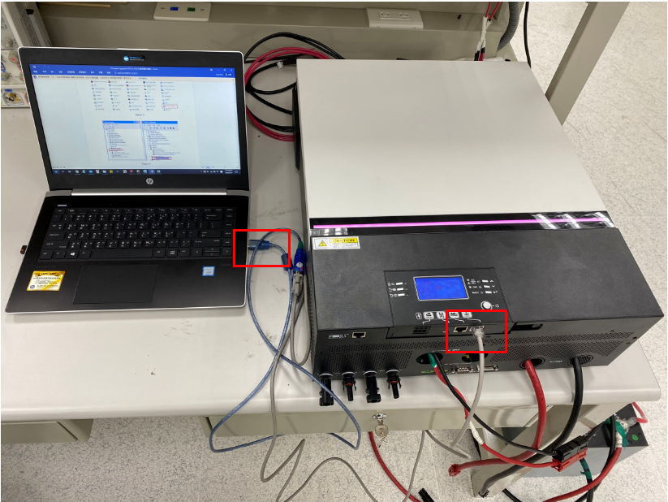
Figure 1

Step2. Please check the COM Port Number as below pictures.
NOTE: Make sure all communication applications which use this COM port are turned off. The application software includes inverter monitoring application software.
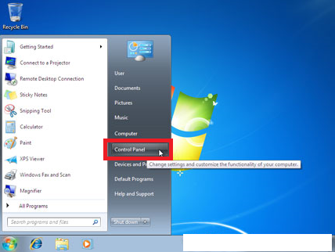
Figure 2
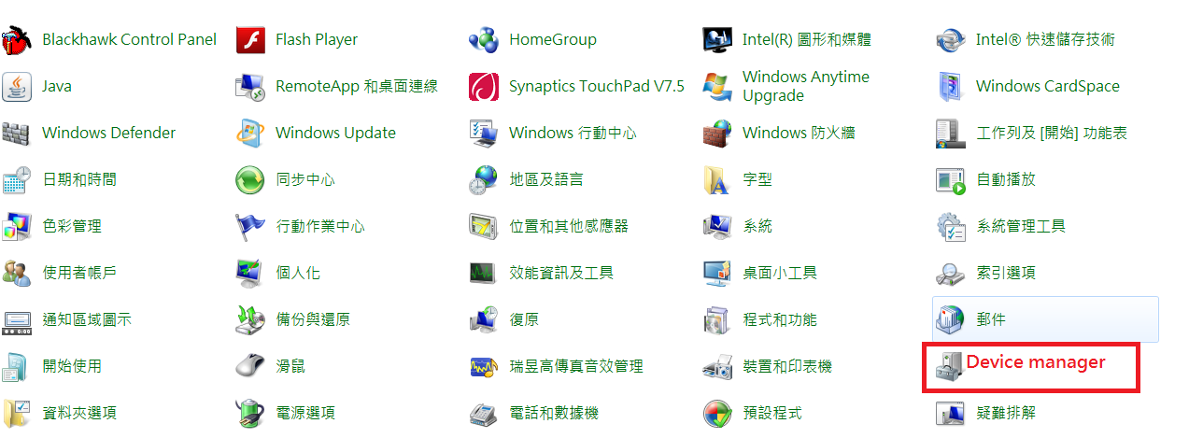
Figure 3

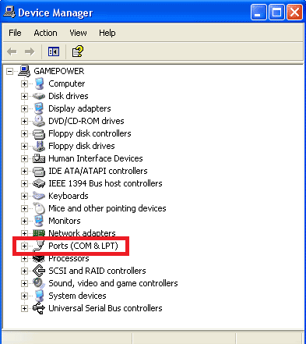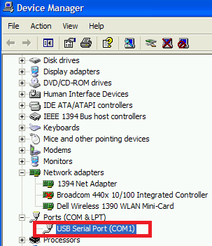
Figure 4

Step3. Double left click the “Reflash” folder, and open the “ReflashTool_Xseries.exe” to run the program. Please refer to below picture.
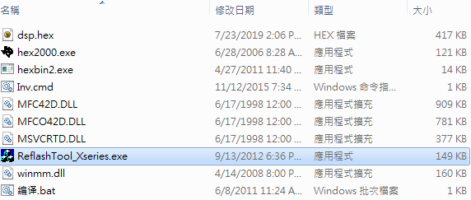
Figure 5
Step4. Click “Update” to upgrade firmware. Please refer to below picture.
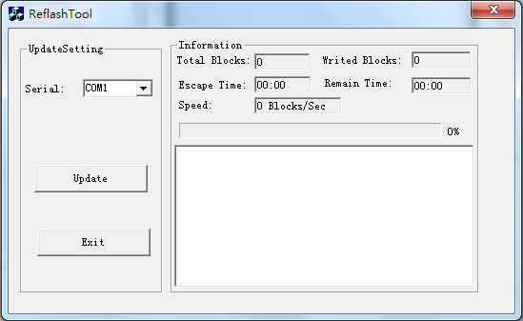
Figure 6

Please wait for about ten seconds. The update will be in progress, LCD will display “UPG YES” and Setting LED 1 will flash once 500ms.
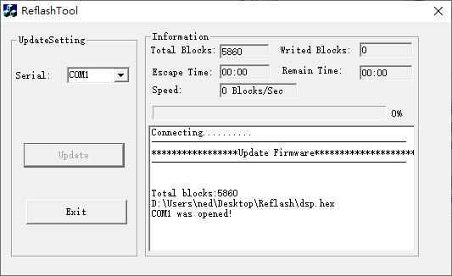
Figure 7

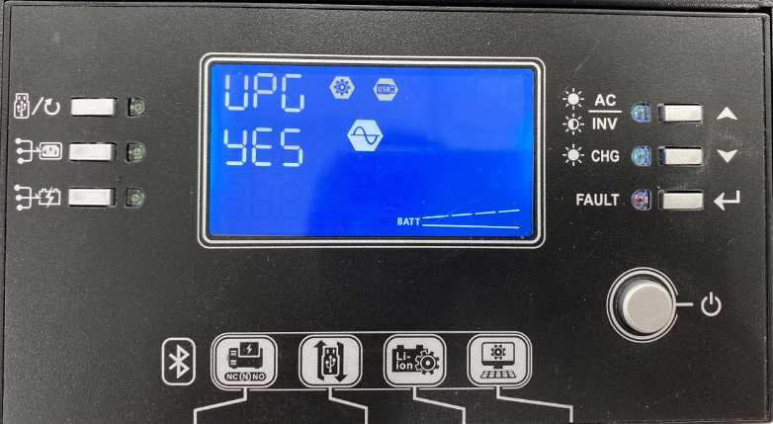
Figure 8

Step5. Once upgraded successfully, you can see the pup-up window as below. Please click “確定” to close the pup-up window. Please refer to below picture.
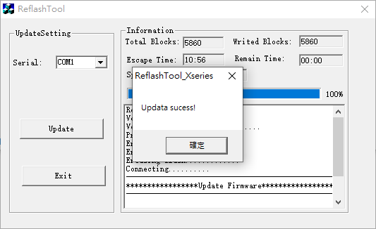
Figure 9

Click “Exit” to exit tool
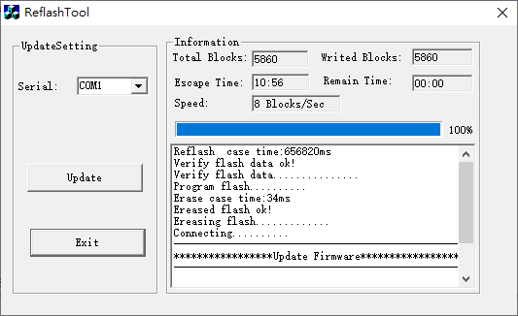
Figure 10

Step7. Please wait for about ten seconds. The LCD will return to main screen.
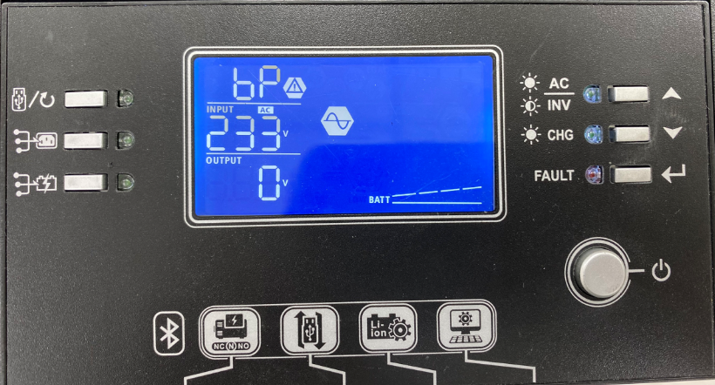
Figure 11

Step8. Please confirm the U1 firmware version is changed via LCD.

